Th1 AN ILL FATED SATELLITE

SOLUTION

1.1 and 1.2
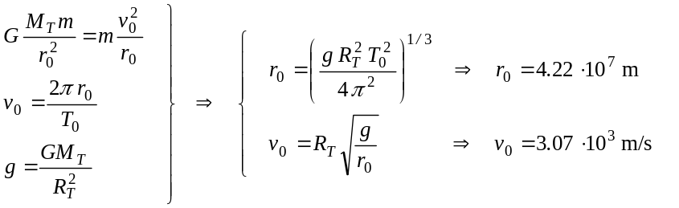
1.3
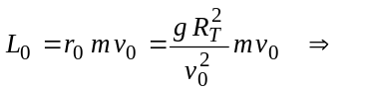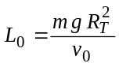
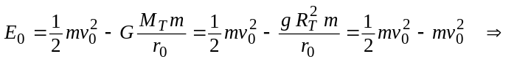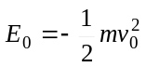
2.1
The value of the semi-latus-rectum l is obtained taking into account that the orbital angular momentum is the same in both orbits. That is
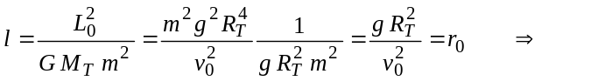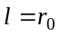
The eccentricity value is
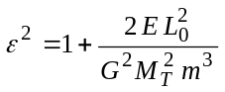
where E is the new satellite mechanical energy
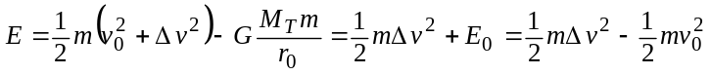
that is
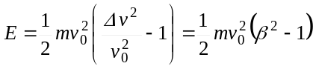
Combining both, one gets 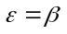
This is an elliptical trajectory because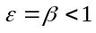.

2.2
The initial and final orbits cross at P, where the satellite engine fired instantaneously (see Figure 4). At this point
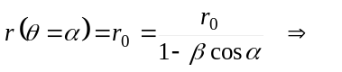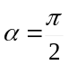
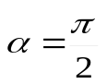
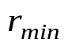
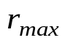
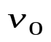
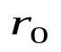
2.3
P
Figure 4
From the trajectory expression one immediately obtains that the maximum and minimum values of r correspond to 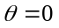 and 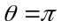 respectively (see Figure 4). Hence, they are given by
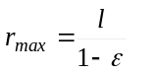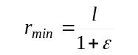
that is
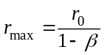 and 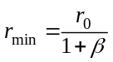
For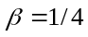, one gets
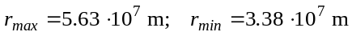
The distances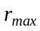 and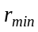 can also be obtained from mechanical energy and angular momentum conservation, taking into account that and are orthogonal at apogee and at perigee
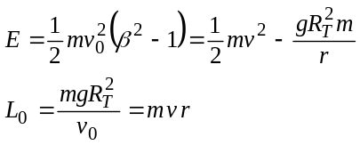
What remains of them, after eliminating v, is a second-degree equation whose solutions are and .
2.4
By the Third Kepler Law, the period T in the new orbit satisfies that
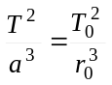
where a, the semi-major axis of the ellipse, is given by
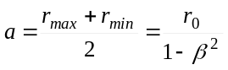
Therefore
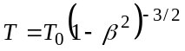
For β = 1/4 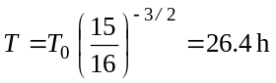
3.1
Only if the satellite follows an open trajectory it can escape from the Earth gravity attraction. Then, the orbit eccentricity has to be equal or larger than one. The minimum boost corresponds to a parabolic trajectory, with ε = 1
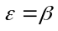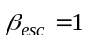
This can also be obtained by using that the total satellite energy has to be zero to reach infinity (E_{p} = 0) without residual velocity (E_{k} = 0)
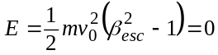
This also arises from or from 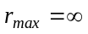.
3.2
Due to 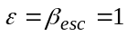, the polar parabola equation is
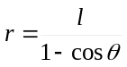
where the semi-latus-rectum continues to be . The minimum Earth - satellite distance corresponds to , where
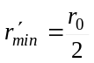
This also arises from energy conservation (for E = 0) and from the equality between the angular momenta (L₀) at the initial point P and at maximum approximation, where and are orthogonal.
4.1
If the satellite escapes to infinity with residual velocity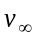, by energy conservation
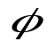
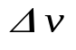
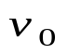
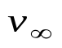
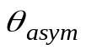
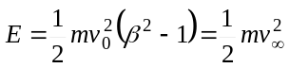
Asymptote
Asymptote
b
Figure 5
P
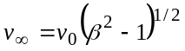
4.2
As 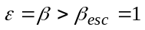 the satellite trajectory will be a hyperbola.
The satellite angular momentum is the same at P than at the point where its residual velocity is (Figure 5), thus
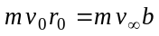
So
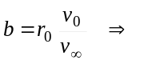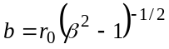

4.3
The angle between each asymptote and the hyperbola axis is that appearing in its polar equation in the limit. This is the angle for which the equation denominator vanishes
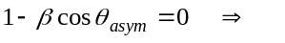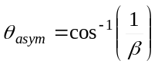
According to Figure 5
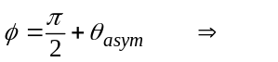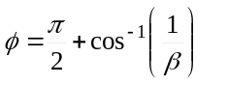
For 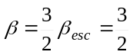, one gets 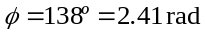

Th 1 ANSWER SHEET

Question | Basic formulas and ideas used | Analytical results | Numerical results | Marking guideline
1.1 | 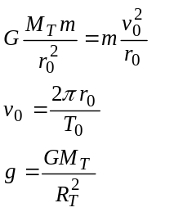 |  | 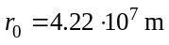 | 0.3
1.2 |  | 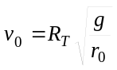 | 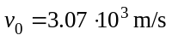 | 0.3 + 0.1
1.3 | 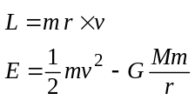 | 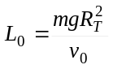 |  | 0.4  0.4
2.1 | Hint on the conical curves |  |  | 0.4  0.5
2.2 | Hint on the conical curves |  |  | 1.0
2.3 | Results of 2.1, or conservation of E and L | 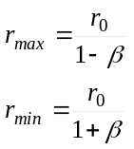 | 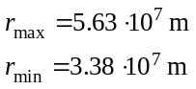 | 1.0 + 0.2
2.4 | Third Kepler's Law | 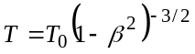 | 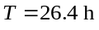 | 0.5 + 0.2
3.1 | ε = 1, E = 0, T = ∞ or  r_{max} = ∞ |  | 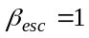 | 0.5
3.2 | ε = 1 and results of 2.1 | 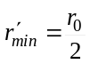 |  | 1.0
4.1 | Conservation of E | 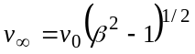 |  | 1.0
4.2 | Conservation of L | 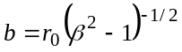 |  | 1.0
4.3 | Hint on the conical curves | 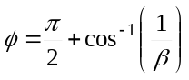 | 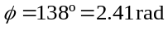 | 1.0 + 0.2

